1. CommonScroll
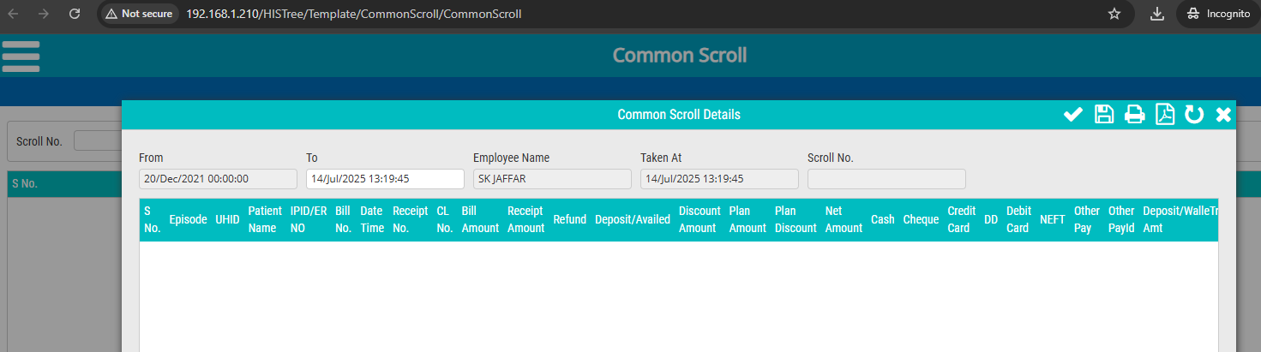

2. Expired Patient Report
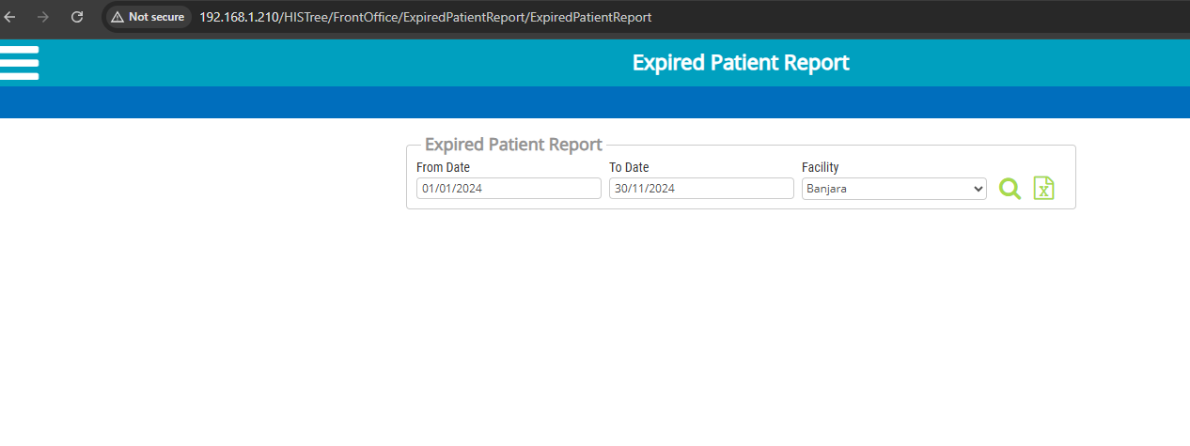
3. Equipment Schedule Report
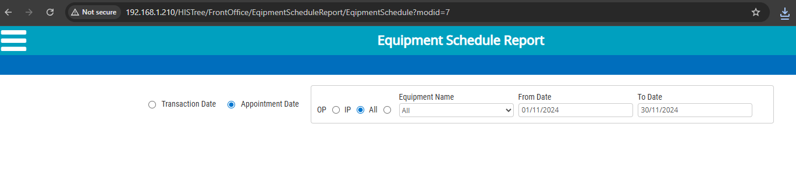
4. Doctor Schedule Report
